Lacquered Glass

JSR lacquered glass has a unique coloured opaque appearance. It is manufactured using special, high quality paint on one side of the glass. This give it a uniform fell and make it highly resistant to heat ,thus ensuring a lasting impression.

Why choose Lacquered glass

* Durable :Lacquering ensures long lasting , beautiful colours
* Easy to use and maintain
* Environment- friendly paints used
* Processing: Can be cut, drilled, ground, beveled and edge-finished or polished

Features

* UV resistance prevent discolouration
* Moisture-Resistance for use in Bathrooms and Kitchen
* Opaque Look

### Application

### Lacquered Glass is ideal for use in domestic and commercial locations which include offices, hotels, museums, theatres etc. for the purpose of: • Wall paneling and column cladding • Furniture • Cabinet, wardrobe and sliders • Partitions, lift lobbies • Signage, writing boards and bathrooms.

Key point – (It will be used in photo)

1. Durable
2. Easy to use and maintain
3. Shiny and opaque look

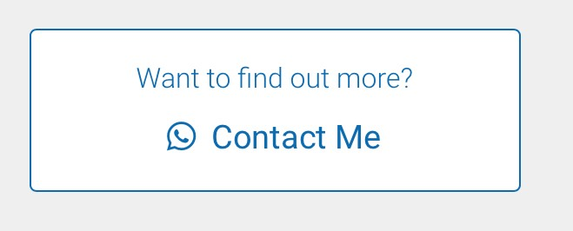

To see variety of samples of (name of the glass) you can drop by at our showroom or contact our representative who will help you out to the best of his knowledge. (This will be copied in every glass section)

DIGITAL Printing

Printing Glass is a modern alternative to canvas printing. This type of glass is created using digital graphics. Digital print technology removes the limitations of traditional glass processing methods, allowing you to get exactly what you want, when you want it and at a price that makes sense. It is direct on Glass multi colour digital printing ranging from whole building facade (including interior and exterior applications) to variable serial number on every glass piece like a car windshield.

Why choose Digital Printing on glass

* Used for decorative purposes
* Aesthetically pleasing
* Play with various colours and shades

Application

* Interior and exterior architectural application
* Wall paneling
* Cabinet, wardrobe and sliders
* Railings
* Many More places its can be used in interior and exterior

Key Points

* Infinite Designs
* Extensive colour & effects palette
* From digital file to glass – directly



Etched Glass

Etched glass is created by applying acidic or abrasive substance on the glass surface to create artistic patterns or designs. The process involves using a strong acid to cut into the unprotected parts of glass surface to create designs

Why choose Etched Glass?

* Offers countless innovative ideas in glass
* A multitude of designs can be created as per the customer’s requirement
* Enhance the aesthetic appeal of the surroundings

Application

* Windows
* Façade
* Doors
* Partitions
* Railings
* Shelves
* Shower and bath enclosures
* Glass walls
* Kitchens

Key Point’s

* Enhance beauty and affordable
* Countless innovative ideas

.



Laminated Fabric Glass

Fabric Laminated glass is manufactured by sandwiching layers of clear PVB/EVA to add texture, colour, and pattern to laminated glass. This product offers a wide range of fabrics within protective glass layers.

Why choose Fabric Glass

* Combines the beauty ,colour & texture of the fabric with the structural strength and practicality
* The interlayer behaves as a security film which can resist any kind of intrusion or impact , thus ensuring safety
* Its acoustic property dampens outside noise.

Key Points

* Structural strength and beauty at the same time
* Add charm to any space



**Looking mirror**

Looking to create an impact in your home that’s a true reflection of the people who live there? Fill any wall with a stylish mirror and not only will you make a striking statement, you’ll give everyone a spot to check themselves out.

Mirrors have a way of setting a polished tone in any decor, adding light and life to its surroundings. Featured on its own on a wall or mixed in with other pieces to create an on-trend gallery wall installation, a mirror will be the dazzling element in any space.

Here are just a few places you can use mirrors.

**Mirrors for An Entryway**

## Mirrors for A Powder Room or Bathroom

## Mirrors for A Bedroom

## Mirrors for A Living Room

## Mirrors for A Dining Room

Key Point

* Eye-catchy look
* Elegant designs
* Unmatched quality



**Pattern Glass**

The attractive design of patterned glasses has been sought-after interior designers for restaurants and resorts, residential and also showrooms. Innovative and classy, designs have the ability to add glamour to the ambiance. That has been used in office vestibules or lobby and can make it more attractive and desirable.

Excellence in design and graceful cuts makes this a prime choice of architects and interior designs alike. Just put it under light and see the magic it weaves into the ambiance. This simply a great option for Hotels, resorts or living room interior. A rich design that gives your home, kitchen or office space a distinguished style.

Key Points

* Enhance beauty and affordable
* Easy to clean



**Wall Paneling**

Utilising glass is one of the best ways to optimize space specially the vertical space of the walls or empty space which cannot be used for anything else.

There are many types of glass available when it comes to enhancing your home décor. Many homeowners today are thinking of ways to enhance the home while keeping it beautiful and modern. Adding glass in a room makes it look larger, brighter and livelier.

Some of the application areas:-

* Hall way
* Entrance wall
* Athletic Studio
* Alcove wall
* Behind large pieces of furniture, such as a bed, office desk or surrounding a fireplace
* Anywhere you’d like to draw out more space, light, colour or energy into a room

Key Point

* Enhance your room and home interior aesthetics
* Customized designs options



Stained glass

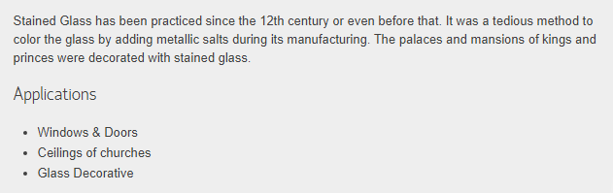

Key Point

1. **Adds beauty and colour**
2. **Energy efficient** and **Low maintenance**



To see variety of samples of (name of the glass) you can drop by at our showroom or contact our representative who will assist you to the best of his knowledge.